
North Bengal International University

Lab Report: 02
Exp Name : Decision Tree using ID3 Algorithm.

Subject : Artificial Intelligent sessional
Subject Code : CSE 0613-3112

Submitted By:
Name : Md. Tanvir Rahman Pranto
Dept : CSE
Roll : 0712340012101005
Semester : 3nd Year, 5th semester.

Submitted To:
Name : Rifa zumana
Designation : Lecturer
Dept : CSE
Date :

Tittle: Decision Tree using ID3 Algorithm.
Theory: A decision tree is a supervised learning model shaped like a flowchart. Internal nodes represent feature tests, branches show outcomes, and leaf nodes provide final decisions. Starting from the root, it follows conditions until a leaf is reached. It’s simple, interpretable, and widely used for classification.
Code:
import math

# Calculate entropy of the dataset
def calculate_entropy(dataset):
outcomes = [row[-1] for row in dataset]
total = len(outcomes)
entropy = 0
for label in set(outcomes):
probability = outcomes.count(label) / total
entropy -= probability * math.log2(probability)
return entropy

# Split dataset based on attribute value
def filter_data(dataset, index, target_value):
return [row for row in dataset if row[index] == target_value]

# Find the best attribute to split on
def choose_best_attribute(dataset):
base_entropy = calculate_entropy(dataset)
max_gain = 0
best_index = -1
num_attributes = len(dataset[0]) - 1

for i in range(num_attributes):
unique_vals = set(row[i] for row in dataset)
weighted_entropy = 0
for val in unique_vals:
subset = filter_data(dataset, i, val)
prob = len(subset) / len(dataset)
weighted_entropy += prob * calculate_entropy(subset)
gain = base_entropy - weighted_entropy
if gain > max_gain:
max_gain = gain
best_index = i
return best_index

# Build the decision tree recursively
def build_tree(dataset, attributes):
labels = [row[-1] for row in dataset]

# If all labels are the same, return that label
if labels.count(labels[0]) == len(labels):
return labels[0]

# If no attributes left, return the majority label
if len(dataset[0]) == 1:
return max(set(labels), key=labels.count)

best_index = choose_best_attribute(dataset)
best_attr = attributes[best_index]
tree = {best_attr: {}}

unique_vals = set(row[best_index] for row in dataset)
for val in unique_vals:
subset = filter_data(dataset, best_index, val)
reduced_attrs = attributes[:best_index] + attributes[best_index+1:]
reduced_data = [row[:best_index] + row[best_index+1:] for row in subset]
tree[best_attr][val] = build_tree(reduced_data, reduced_attrs)

return tree

# Sample dataset
data = [
["Sunny", "Hot", "High", "Weak", "No"],
["Sunny", "Hot", "High", "Strong", "No"],
["Overcast", "Hot", "High", "Weak", "Yes"],
["Rain", "Mild", "High", "Weak", "Yes"],
["Rain", "Cool", "Normal", "Weak", "Yes"],
["Rain", "Cool", "Normal", "Strong", "No"],
["Overcast", "Cool", "Normal", "Strong", "Yes"],
]

# Feature names
features = ["Outlook", "Temp", "Humidity", "Wind"]

# Build and print the decision tree
decision_tree = build_tree(data, features)
print(decision_tree)

Output:
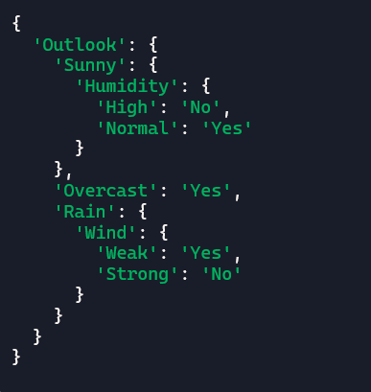
Description: The program builds a decision tree using the ID3 algorithm. Entropy measures data uncertainty, and the feature offering maximum information gain is chosen. The dataset is split accordingly, and the process repeats until classification completes. The resulting tree predicts outcomes for unseen inputs. for graph traversal, as it can successfully find the shortest path between the starting node and the target node.

